Frequently Asked Questions
Q: What are the current membership and class levels at Beta Epsilon?
A: Total membership is currently 17, not including Associate Members (pledges) to be added during the 2022 Fall Rush:
Freshman: 0
Sophomore: 4
Junior: 10
Senior: 3

Q: Is the Greek community a significant part of the UCD student body?
A: Sorority and fraternity life at UCD consists of 6 governing councils, 55 chapters and 1,926 Aggies or 6% of the undergraduate population. As a percentage of the total, the number of Greek-affiliated students has remained constant over the years. The six councils and their characteristics include:

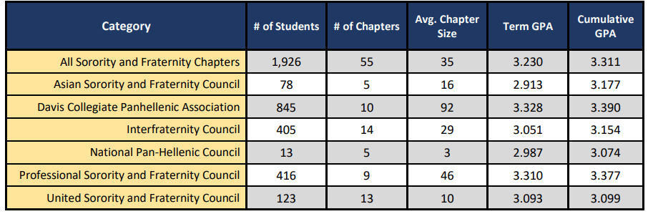

Beta Epsilon is one of 14 fraternities that comprise the Interfraternity Council (IFC). Of the 9 fraternities that existed in the 1960s, only 5 remain active today.

It is not clear how many of the 14 IFC fraternities have houses. Not all fraternities and sororities provide housing for their members; some provide housing only for chapter officers. Statistics as to the numbers of houses, their capacities and the rents charged are not easily ascertainable. At least one fraternity demolished and reconstructed its current house at the same location in 2012. Most other fraternities with housing occupy former residential structures. Some are on campus or near the campus and others are considerable distances from campus. Comparisons of involvement in campus leadership, athletics and other parameters among fraternities are not among the information available to us.

Q: How do housing costs at Beta Epsilon compare with alternative housing options at Davis?

Beta Epsilon members sign a 9-month lease to occupy the premises at below market rates. Rent charged by the Beta Epsilon Association for the 2022-23 Academic Year includes utilities and is $800 per month for those living in. A Parlor Fee of $96 per month is charged for those living elsewhere. Rent does not include the $28 per month each member contributes to the Association as long as they are an enrolled student at UCD, fees levied by the national fraternity, and fees added by the undergraduate members to fund their social activities.

For 2022-23, University-owned Residence Hall housing, including utilities, is $1,537 for a single, $1,335 per person for a double, and $1,070 per person for a triple. University-owned apartments, including utilities, are available at $2,331 per month for a single occupancy Studio, $1,606 per person for a single occupancy bedroom in a shared apartment, and $1,070 for a double occupancy bedroom in a shared apartment.

For 2022-23, privately-owned housing is available throughout the City of Davis at varying rates that do not include utilities. Typically, private leases are for 12 months, not 9 months. The vacancy rate in Davis has been less than 2% for a number of years.

Q: What is the most recent Chapter GPA and how does that compare with the other living groups?
A: Beta Epsilon’s GPA for the Winter 2022 quarter was 2.875; Cumulative GPA was 3.171.
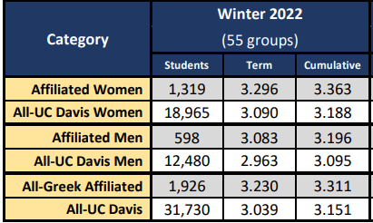
UCD’s Center for Student Involvement website may have updated information: GPA Reports | CSI (ucdavis.edu)

Q: What is the Chapter’s current status with the University and how has that changed in recent years?

A: As registered student organizations, sororities and fraternities are closely monitored by the University and the respective governing councils. Violations of university policies are subject to punishments ranging from probation to revocation of recognition.

In 2012, the Chapter had its status changed by the national fraternity, from Chapter to Colony, following a years-long pattern of risk management issues, including hazing, alcohol violations and inability to live out its core commitment to an Associate member philosophy for new members. The status change was part of a larger package of sanctions from the University as well. The action forced the Chapter to meet the chartering standards again, with the help of the national fraternity as a guide through a “reset” period. The process was used to reeducate the men on what it means to be a Theta Xi and enabled the Chapter to rid itself of many “bad actors.”

In August 2016, the Board of Directors adopted a policy on Human Dignity and the Use of Controlled Substances. In part, such actions were aimed at reducing the consumption of alcohol on the premises.

In November 2016, Beta Epsilon was found guilty by the IFC of violating IFC Bylaws and the City of Davis Good Neighbor Policy and sanctioned for the remainder of the academic year. Alcohol consumption was a contributing factor. The University placed the chapter on Conditional Registration through the end of the school year. In December of that year, the Board of Directors took some additional steps, assisting the Chapter in revising its Risk Management, Good Neighbor, and other policies in an effort to realign the Chapter’s culture to promote the objects and purposes of Theta Xi.

After the school year ended in June 2017, when the undergraduates returned home for the summer, a visiting alumnus who had graduated two years earlier trespassed and gained access to the property and set off illegal fireworks late at night. The University, holding the chapter responsible for anything that occurs on its property, cited an unspecified “continuing pattern of behavior” that it found to be unacceptable. Its initial punishment was to revoke the Chapter’s registration as a student organization for at least a 5-year period. On appeal, it reduced the punishment to a 2-year conditional registration status. Conditional registration is tantamount to probation, which restricts the Chapter’s association with the sorority community and negatively impacts its recruiting efforts. That probation ended in September 2019. Though the Board of Directors assisted the Chapter in its appeal and found the final punishment to be grossly unfair to the undergraduates who played no role in the incident in question, it was helpless to do anything other than to encourage the Chapter to learn from the experience and to refocus its efforts on rebuilding its membership.

The Board acted to assist the Chapter in adopting a new vision for itself. Members who were not supportive of the new vision were asked to sever ties with the fraternity and several did so. With a reduced membership, the Board of Directors expected the Chapter to rebuild itself in a manner that focuses on and reflects the purpose of Theta Xi.

The Chapter is on probation through the Fall Quarter of 2022-23 as the result of an allegation that it served alcohol to an underage student at a party. When allegations are made, they are made anonymously and dealt with by UCD’s Office of Student Support and Judicial Affairs. Decisions are based on an investigation and private discussions involving the relevant parties. Decisions are based on a preponderance of evidence, typical rules of due process applicable in a judiciary proceeding are not applicable in such proceedings, and there may be no right to an appeal of the decision rendered. Current Chapter leadership has the full confidence of the Board of Directors.

Q: Who owns and manages the current property occupied by the Chapter?

A: The owner of the properties at 503 and 515 1st Street is the Beta Epsilon Association of Theta Xi, a California non-profit corporation having no capital stock. The former lot at 509 1st Street has been merged with the lot at 503 1st Street. Among the purposes of the corporation is “to provide and maintain adequate housing facilities for the individual members and the Chapter activities of the Beta Epsilon Chapter of Theta Xi and of any chapter of Theta Xi which may be chartered to succeed said Beta Epsilon Chapter, and to do that so long as any active chapter shall reasonably exist.”

Membership in the corporation is limited to members in good standing of the Beta Epsilon Chapter and does not entitle any member to any actual property right in the assets; the sole and only rights accruing to members is the right to a voice in the management of its affairs as contained in the Articles of Incorporation and Bylaws.

The business of the corporation is controlled by an elected Board of Directors consisting of two directors who are active members of the Beta Epsilon Chapter and nine directors who are alumni members of the Chapter. Alumni Directors are elected at the annual meeting in April to 3-year staggered terms. Directors meet at the Chapter house monthly, on the first Monday after the 10th of the month. There is an agenda for each meeting and minutes are maintained. Directors do not receive compensation for services rendered. The current Board of Directors consists of:

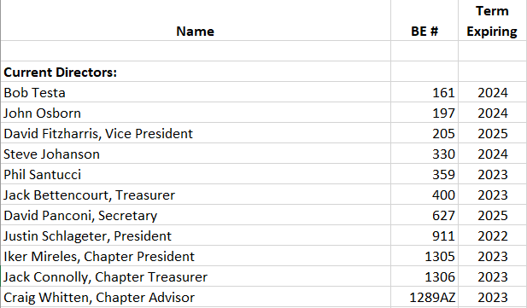

Q: What is the current status of the project?

A: Since the fall of 2016, the Board has been pursuing a plan aimed at restoring the Chapter to perform at historic levels to maintain an environment that, through fellowship and alumni guidance, lead to the wholesome mental, moral, physical, and spiritual growth that is the purpose of the Theta Xi Fraternity. In so doing it has:

- A fully functioning Board of Directors;
- Developed a plan for a new, 3-story chapter house, now under construction, with occupancy planned for the fall of 2023. Though at its peak, the chapter houses accommodated 55 live-in members, the Board determined the realistic capacity of the existing houses to be 38. The new house is designed to accommodate 35 live-in members, sited on 70% of the land that was the site of the former 3 houses;
- Developed a vision for a “new, sustainable Beta Epsilon Chapter of Theta Xi;” and
- Engaged the services of outside sources to help bring the new vision and the new house to fruition, including a structural engineering firm, an architect, a historic resources management consultant, a fundraising company and legal representation.
The Board reviewed a number of alternatives before settling on the current proposal. The objectives of the proposed project are to:
- Address deficiencies in the structural integrity of the three houses used to house the undergraduate members of the Theta Xi Fraternity on First Street in Davis, CA, as identified in the report by our engineering consultant;
- Renovate the subject properties in a way that provides for the needs of UCD students by ensuring that housing is competitive both in rent and amenities available within the City of Davis, including on-campus housing, in order to ensure the sustainability of the fraternity;
- Use the value embedded in the three owned lots to assist in funding the renovation project by consolidating the housing needs of the fraternity onto a smaller footprint;
- Construct the new building with features that will allow it to achieve an elevated level of energy efficiency and reduce ongoing maintenance costs; and
- Continue to use the new facility as classrooms to achieve the purpose of Theta Xi.
Q: What is the cost of the project and how will it be paid for?
A: Our plan envisions a total project cost estimated to be about $5.3 million, to be financed by a construction loan, to be rolled into a mortgage, a capital campaign to grow the Building Fund and the sale of the original lot on which the TX House sits.
The initial rent is expected to be between about $850 per month for 9-months.
Our goal is to become debt free sooner than the 25-year mortgage suggests. Rent combined with donations and other income should be sufficient to provide operating funds for annually recurring expenses such as taxes, insurance, management, utilities, debt servicing, janitorial services and transfers to the Building and Scholarship Funds. We envision that the Building Fund will be used for debt reduction and the repair and replacement of the major components of the property. We envision that the Scholarship Fund will be expanded to increase the size of scholarship awards.
Among the assumptions we have used is a total membership of at least 60, a full occupancy, and rent to be established at about 70-75% of the cost of on-campus housing charged by the University.
Q: What is the status of the fundraising efforts?
A: The fundraising effort is planned to wind down by the end of 2022. By then, we expect that we will have received written commitments from over 200 alumni members pledging a minimum $1.63 million to the project. By mid-September 2022, we have received over 95% of the funds the alumni have committed. Pledges have been made over a 5-year period, supplemented by one-time gifts. Monies contributed to the project via the Theta Xi Foundation are tax-deductible to the donor and can only be used for the educational aspects of the project which we estimate will be about one third of the total cost.
Q: How can I contribute?
A: We have set up two options for gifts, depending on whether the donor wishes to take advantage of tax deductions offered by the IRS in filing their income tax returns. For those who may no longer itemize their deductions on their income tax return and instead take the new standard deduction when filing their returns, our preference is that their contribution go to the Beta Epsilon Association Building Fund because that fund provides the greatest flexibility to the Board of Directors in terms of accessing the funds and put them to their intended purpose of building the house. The other option is to direct your gift to the national fraternity's Theta Xi Foundation and its Beta Epsilon Chapter Education Account. As a charitable foundation, those funds can only be used for the "educational" aspects of a new house, such as libraries and study rooms, based on IRS guidelines. For us to access those funds, the Board of Directors must apply for a grant, accompanied by certification by a tax lawyer that the funds will be used for educational purposes. Pledges and donations have been running approximately 52% to the Theta Xi Foundation and 48% to the Building Fund.
All gifts should be designated either for the Beta Epsilon Association Building Fund (preferred) or the Theta Xi Foundation, Beta Epsilon Chapter Education Account, and mailed to:
Theta Xi, University of California-Davis
Payment Processing
P.O. Box 2187
Columbus, GA 31902-2187

Q: Has the Board received City of Davis approval to proceed?
A: Our application for a building permit was approved 4 years after we made our formal filing. Construction commenced with the demolition of the structures on the Jackson and Bryson lots in April of 2022. Completion is anticipated in August 2023.
Q: What happens to the Association’s assets should the chapter cease to exist?
A: In the event that the Chapter becomes nonexistent, the Board of Directors may find it expedient to dissolve the nonprofit corporation. After discharging its debts, any remaining funds are to be conveyed to a Section 501(C) (2), (3), (7), or (9) charitable organization as defined in the Internal Revenue Code.
Q: DID the Association considered other models for redevelopment to provide improved housing for the BE chapter (for example having a house that accommodates fewer men living in smaller investment) but has a large membership that rotates members through live in status)? If so, what were they?
A: The Board of Directors considered a number of alternatives to provide improved housing for the Chapter, including relocation to on-campus housing or alternative off-campus housing; renovating the existing structures; constructing a one story “connector” between the Jackson and Bryson houses; and demolishing Jackson & Bryson and constructing a new, smaller two-story house to supplement the existing TX house. Among the critical factors guiding the decision to construct the new 3-story house was the need to extract value from the existing property to help fund the project, the City’s likely disapproval of any proposal to replace the existing houses with any two story structure, the lack of availability of alternative sites in proximity to the campus, the challenges faced with attempting to relocate on-campus, and the ability to be competitive with alternative housing available within the City. The Board did not specifically consider downsizing to the original TX House with a maximum live-in capacity of 16.
Q: What are the current Beta Epsilon, Theta Xi national, and UC Davis policies for the use of alcohol and other legal drugs on Beta Epsilon chapter property and what are the ramifications of these for liability concerns?
A: UCD strives to maintain a campus free from the illegal use, possession, or distribution of controlled substances. All state laws regarding alcohol and drug use apply on campus. All drugs made illegal by state and federal law are also prohibited by University policy. The National Fraternity’s Risk Management Policy and the Chapter’s Risk Management Policy also address the issue of alcohol and drugs. The Board of Directors’ policy on “Human Dignity and the Use of Controlled Substances at Theta Xi” augments University and national fraternity policies.
Limited and responsible consumption of alcohol is permitted on Association property by those aged 21 and over within the bedroom areas of the property at any time. Alcohol in the individual designated living space is for personal consumption only; not distribution to others. In addition, limited and responsible consumption of alcohol is permitted in other areas of Association property or at chapter-sponsored events by those aged 21 and over when authorized in advance by the Association Board of Directors. Alcohol is prohibited elsewhere on Association property. Any violation of Association policy regarding alcohol and controlled substance use is subject to disciplinary action; individuals are subject to penalties ranging from warnings to cancellation of any residential or use agreement and termination of membership in Theta Xi.
Liability insurance is maintained by the national fraternity and the Association.

